[VJC 2025 Prelim P1 Q4]
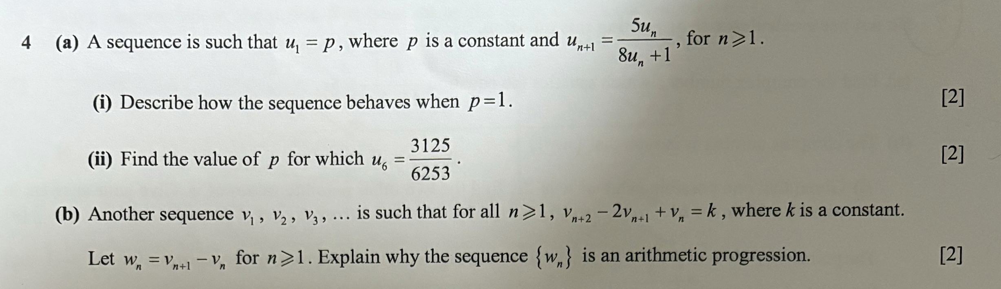

[ACJC 2025 Prelim P2 Q3]
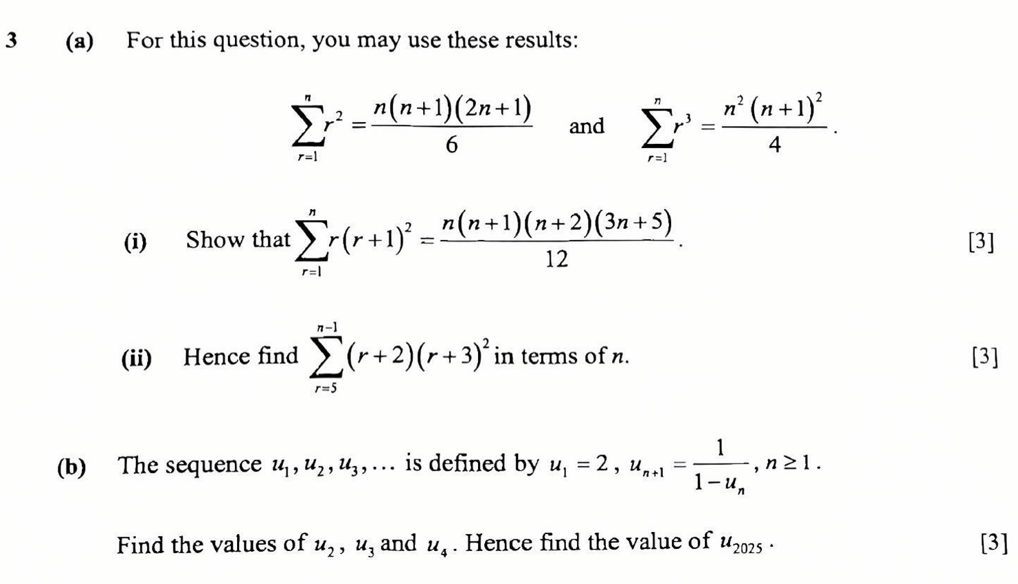

[HCI 2025 Prelim P1 Q2]
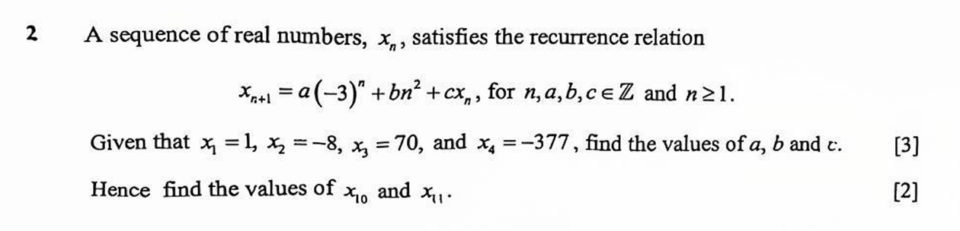

[TJC 2025 Prelim P1 Q1]
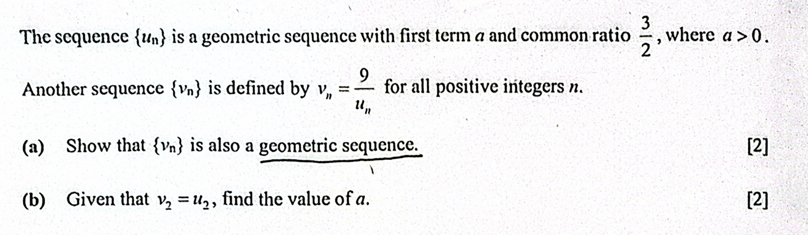

[TMJC 2025 Prelim P1 Q5]
